**Design and development of classification model for the knee osteoarthritis**

**Abstract**

Knee osteoarthritis is a disease that affects multiple individual’s especially elderly people. Early diagnosis helps to reduce the consequences of the osteoarthritis and multiple researchers are enabled for the early detection. In this research the knee osteoarthritis is identified and classified using the optimization based deep CNN which provides efficient results without complexities.

**1. Introduction**

Knee Osteoarthritis (OA) is a human knee joint condition that primarily impacts cartilage. Cartilage has a significant role to perform in leg movement. In OA, the top layer of cartilage disintegrates and deteriorates resulting in intense pain [10][2]. OsteoArthritis (OA) is a progressive joint disease causing pain, swelling, stiffness and loss of function [15][16]. OA is a chronic disease, whose origin is not well understood. It is considered the most common form of arthritis and is characterized by cartilage degradation and bone changes [26]. At the early stage of the disease it is challenging to diagnose OA as it has been suggested that the first changes occur in the subchondral bone [27] before the occurrence of joint space narrowing and osteophytes [28]. Hence, early detection, diagnosis and intervention are strongly desired to overcome this highly disabling disease since early-stage treatment could prevent the breakdown of cartilage and bone [1]. Knee OA is a kind of chronic lesion with extremely high incidence among the elderly, obese, and those with a sedentary lifestyle [8]. The basic radiological symptoms of osteoarthritis which cause human knees to be malformed are subchondral sclerosis, joint space narrowing, and osteophytes (bone spurs) [13]. Among these joint space narrowing, also known as cartilage loss, is considered to be the key feature of osteoarthritis [11][12][4]. Knee OA detection consists of classifying a knee radiograph into healthy or OA [14][1].

Osteoarthritis is the most common disabling and financially burdensome of all musculoskeletal diseases, and prevalence is rising. It occurs most frequently in the knee, affecting 1 in 5 adults over the age of 45 [17][3]. During 2013–2015, 54.4 million people had arthritis and it is estimated to have an impact on 78.4 million adults by 2040 [18]. Osteoarthritis is considered to be the most usual type of arthritis affecting millions of people yearly and results in more than 7 million physician visits per year [19][4]. In clinics, the traditional Knee OsteoArthritis detection is visual inspection of patients’ examination results (e. g. X-ray, MRI, and CT) by experienced physicians. However, these examination tools are generally large-scale, and often harmful to the human bodies, in addition, the examination cost is very expensive so that it is impossible for patients to keep the daily monitoring. Comparing with these examinations, the vibroarthrographic (VAG) examination, which is a low-costly, atraumatic, and at-home way, may open up new alternatives to KOA detection in clinic [20][6]. For several years, researchers studied X-ray analysis and diagnosis using computer-assisted methods. However, automatic OA severity assessment remains challenging for two reasons: (1) the lesion area occupies a small portion of the X-ray image. The irrelevant parts like clothes, tissues, or muscles overwhelm the cartilage status and mislead final decisions. (2) As bones differ in shape and density from one to another, it is challenging to establish standard diagnostic criteria [9].

Clinical detection of knee OA relies on a combination of patient reported symptoms and medical imaging of cartilage and subchondral bone degradation [3]. With the advent of the information age, especially the digital age, medical imaging has become an important supplemental approach to clinical diagnosis and treatment. Among these techniques, X-ray, ultrasound, Computed Tomography (CT), and Magnetic Resonance Imaging (MRI) have been widely used in a series of links including medical diagnosis, preoperative planning, treatment, and postoperative monitoring [21][22]][7]. Despite the development of newer imaging techniques, the X-ray imaging remains the most accessible and used tool in the diagnosis of the knee OA, because it is noninvasive, cheap, convenient, simple and rapid [23][8]. Subtle differences in textures and intensity variations within an X-ray knee image can be detected by computer-aided image analysis methods, without clinical bias. These approaches have been employed to analyze texture and intensity changes in the bone of the knee [1]. This diagnosis tool could be used for clinical studies such as the evaluation of medication, intra-articular injections, or surgical interventions that have an effect on the progression of OA. Recently, deep learning has been widely used for different applications such as computer vision (CV) and nature language process (NLP). Convolutional neural networks (CNNs) have demonstrated greater representational and hierarchical learning ability in many applications, which are also highly successful in medical imaging analysis [24]. Automatic diagnosis of knee OA severity has been considered as image classification tasks, which are extremely wellsuited for CNNs [25][8].

**2. Literature survey**

|  |  |  |  |  |
| --- | --- | --- | --- | --- |
| **S.no** | **Authors** | **Methods** | **Advantages** | **Disadvantages** |
| 1. | Abdelbasset brahim *et al.*[1] | Automated computer-aided diagnosis approach. | Able to make predictions on unseen data | Age and gender were not taken into account. |
| 2 | Shivanand s. Gornale *et al.*[2] | Hu’s invariant moments | Works well even in distorted images. | Sensitive to higher data redundancy. |
| 3. | Costas yiallourides *et al*.[3] | Non-invasive detection of knee osteoarthritis | Have the capability to carry significantly discriminant information. | Higher frequencies lead to the diminishing of auc regions. |
| 4. | Mahrukh saleem *et al.*[4] | Computer-vision-based system | Data biasedness in precision and recall is minimized. | Higher execution time. |
| 5. | Yuntang wang *et al*.[6] | Kernel-radius-based feature extraction method, automatic KOA detection method | It is difficult to process vag signal. This technique automatically processes the VAG signal. | The efficacy is not proved in real time environment. |
| 6. | Yongping li *et al*.[7] | Automatic recognition system | Highest recognition rate for determination of intra-articular loose bodies. | Lowest recognition rate for determination of rugged articular surface. |
| 7. | Bin liu *et al*.[8] | Automatic diagnosis of knee OA based on an end-to-end deep learning method. | Model can directly locate the location of the knee joint in the knee x-ray images and quantify the severity. | Dependency of the model is high on high quality training data. |
| 8. | Yifan wang et al.[9] | Knee osteoarthritis diagnosis method based on  Deep learning | All adjustments are handled internally, such as resizing and enhancing. | The granularity of the region can be enhanced further. |

**3. Challenges**

* It was difficult to separate other body sounds such as muscle activity from articular cartilage sounds [3]. Knee radiographic images are very sensitive to unintended defects that may create complications in the study of bone structures. It may result in the experts taking more time to analyse the Knee x-ray and infer the existence of OA [2].
* Hand drawn contours and cropping of the joint area is used for region of interest (ROI) segmentation which is tedious and time consuming [4].
* The prime cause for geometric distortions of cartilage region in knee X-ray images is the progression of OA, which could be misrepresented due to filming, handling, and digitization during image acquisition. It may become difficult in extracting the significant regions from such distorted images [2].
* It may become difficult in extracting the significant regions from such distorted images. It is also a difficult to retrieve the relevant region when the images get distorted by some geometric deformation [2].
* Current imaging methods such as X-ray, Magnetic Resonance Imaging (MRI) and ultrasound have poor sensitivity in early disease and as a result, at the time of diagnosis, OA is already at a progressed stage, and understanding of its cause and development is still limited [3].

**Objectives**

* To analyze the methods introduced for the knee osteoarthritis classification model in the previous researches.
* To explore the mathematical model used for the optimization of deep CNN.
* To classify the knee osteoarthritis using the deep CNN classifier with high accuracy rates.

**4. Problem statement**

* Some conventional osteoarthritis detection methods fail to extract the region of interest which increases the detection accuracy.

**Solution**

In this research the region of interest is extracted using the circular Fourier transformation method with high accuracy.

* The noises present in the image will affect the performance of the classifier which degrades the recognition rates.

**Solution**

Hence the enhancement of the process is carried out using the multivariate linear regression and histogram equalization and quantization.

**4. Methodology**

The main intention of the research is to design and develop a classification model for the knee osteoarthritis inorder to detect the disease in early time. Initially the data will be collected from the Osteoarthritis Initiative (OAI) database [28] and the preprocessing is performed for the enhancement of the data. The preprocessing is necessary for making the data suitable for the approaches and here the preprocessing is performed after the extraction of Region of Interest (ROI) using circular fourier filtering, Histogram equalization & normalization and Intensity normalization using multivariate linear regression (MLR). The strength of the bone is provided by the trabecular bone (TB) and is separated from the X-ray image using the circular fourier filtering for obtaining the most significant information. The trabecular bone consists of complex structure; hence the image should be with high contrast for obtaining the reliable information. The high contrast image is obtained by enhancing the separated trabecular bone image from the X-ray by histogram equalization and normalization. Furthermore the contrast of the image is enhanced by the intensity normalization performed by multivariate linear regression. The preprocessed image is then subjected to the hybrid pretrained model based feature map generator for the obtaining of the most relevant features. Then the features are subjected to the optimized deep CNN model for the classification purposes. The optimization of the classifier is performed using the grey wolf and particle swarm optimization which effectively tunes and optimizes the classifier. In grey wolf optimization the prey is sorted when it is alone and in particle swarm optimization the attack is performed by the social strategy of grouped behavior. The classification of the affected region in the knee is performed based on the intensity of the pixels, where the combined set of pixels shows the strongest region and the individual pixels shows the weakest region. Contrasting, the classification with optimization, the grey wolf optimization helps to identify the weakest pixels and the particle swarm, identifies the strongest pixels, which enhances the classification. Finally, the classification of the affected region is performed. The classification is performed using the software MATLAB and the supremacy of the research is proved by measuring the parameters precision, recall and f1 measure. Figure.1 shows the proposed model for the classification of osteoarthritis disease.

**INPUT IMAGE**

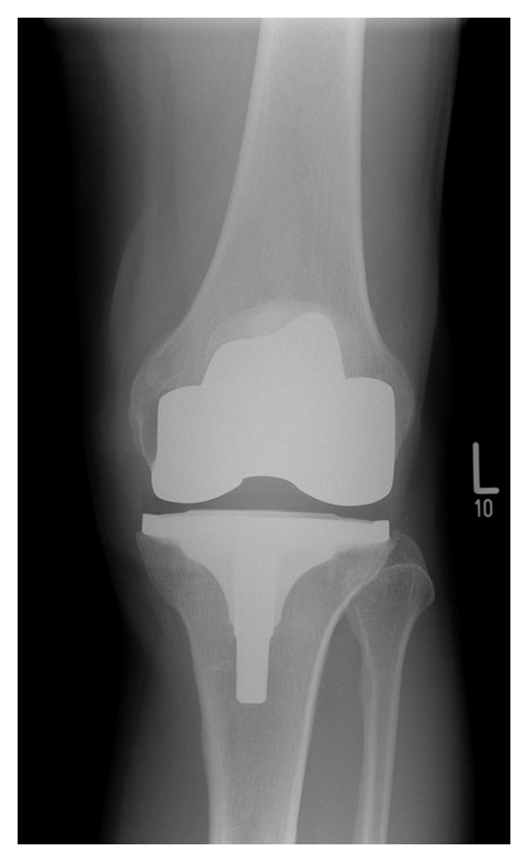

Preprocessing and ROI extraction

Circular fourier transformation

Histogram equalization and quantization

Multivariate linear regression

Hybrid pretrained model based feature map generation

Optimized deep CNN

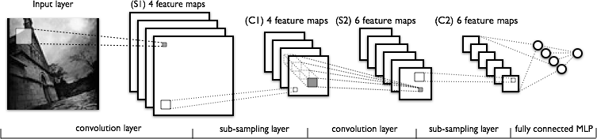

Trained model

Test data

Classification output

**Figure 1. Schematic representation of the osteoarthritis classification model**

**5. Advantages of proposed method over existing approaches**

The medical images are often affected by noise or any other distortion. In this research, the resolution of the image is greatly enhanced during the preprocessing stage using the techniques multivariate linear regression, circular fourier transformation, Histogram equalization and quantization. The preprocessing is performed after the extraction of region of interest (ROI), which helps to focus on the significant features and the usage of optimization in the deep CNN model helps to attain greater performance compared with the state of art methods. The execution time also reduced in the proposed research due to the optimization implemented in the deep CNN classifier.

**6. Advantages of the proposed method**

The combined techniques of multivariate linear regression, circular fourier transformation, Histogram equalization and quantization are introduced in the preprocessing stage which helps in identification of the variables, from the selected region and furthermore enhances the quality of the image. The deep CNN classifier is employed with hybrid optimization, where the optimization is carried using the grey wolf and particle swarm optimization that optimize the classifier and effectively tunes the classifier helps in attaining better performance in the classification.

**7. Inventive steps**

Implementation of hybrid optimization in the deep CNN classifier is the most significant step involved in this research. Here the grey wolf optimization poses the characteristics of social hierarchy, encircling, searching, hunting and attacking the prey. Similarly the particle swarm optimization provides optimal solution for each individual. As an innovative step the characteristics of the prey encircled by the grey wolf will be considered so that the weakest pixels can be determined using this mechanism and the velocity factor of the particle swarm optimization helps to reduce the complexity, and this combined characteristics will provide high accurate solution with less time complexity.

**8. Features of the proposed methodology**

The optimization employed in the deep CNN classifier is the most highlighted feature in the research. Although hybridized optimizations are used in various researchers, the proposed optimizations have the capability to attain more accuracy and higher relevancy**.**

**9. Conclusion**

Early diagnose of osteoarthritis helps to blead a healthy life and avoids the congestions caused due to the disease. In this research the data are collected and the region of interest gets extracted and enhanced and as a significant step the optimization will be enabled in the classifier. The efficiency of the proposed method will be proved using the evaluation metrics precision, recall and f1 measure which is believed to attain above 95%.

**References**

[1] Brahim, Abdelbasset, Rachid Jennane, Rabia Riad, Thomas Janvier, Laila Khedher, Hechmi Toumi, and Eric Lespessailles, "A decision support tool for early detection of knee OsteoArthritis using X-ray imaging and machine learning: Data from the OsteoArthritis Initiative," in Computerized Medical Imaging and Graphics, Vol.73, pp.11-18, 2019.

[2] Gornale, Shivanand S., Pooja U. Patravali, and Prakash S. Hiremath, "Automatic Detection and Classification of Knee Osteoarthritis Using Hu's Invariant Moments," in Frontiers in Robotics and AI, pp.48, 2020.

[3] Naylor, P., and C. Yiallourides, "Time-frequency analysis and parameterisation of knee sounds for non-invasive detection of osteoarthritis," in Institute of Electrical and Electronics Engineers, 2020.

[4] Saleem, Mahrukh, Muhammad Shahid Farid, Saqib Saleem, and Muhammad Hassan Khan. "X-ray image analysis for automated knee osteoarthritis detection," in Signal, Image and Video Processing, Vol.14, no.6, pp.1079-1087, 2020.

[5] Kiselev, Joern, Burkhard Ziegler, Hans-Joachim Schwalbe, R. P. Franke, and Udo Wolf, "Detection of osteoarthritis using acoustic emission analysis," in Medical Engineering & Physics, Vol. 65, pp.57-60, 2019.

[6] Wang, Yuntang, Tiantian Zheng, Jiangling Song, and Weidong Gao, "A novel automatic Knee Osteoarthritis detection method based on vibroarthrographic signals," in Biomedical Signal Processing and Control, Vol.68, pp.102796, 2021.

[7] Li, Yongping, Ning Xu, and Qiang Lyu, "Construction of a knee osteoarthritis diagnostic system based on X-ray image processing," in Cluster Computing, Vol.22, no.6, pp.15533-15540, 2019.

[8] Liu, Bin, Jianxu Luo, and Huan Huang, "Toward automatic quantification of knee osteoarthritis severity using improved Faster R-CNN," in International journal of computer assisted radiology and surgery, Vol.15, no.3, pp.457-466, 2020.

[9] Wang, Yifan, Xianan Wang, Tianning Gao, Le Du, and Wei Liu, "An automatic knee osteoarthritis diagnosis method based on deep learning: data from the osteoarthritis initiative," in Journal of Healthcare Engineering, Vol. 2021, 2021.

[10] Caselles, Vicent, Ron Kimmel, and Guillermo Sapiro, "Geodesic active contours," in Proceedings of IEEE international conference on computer vision, pp.694-699, IEEE, 1995.

[11] Altman, Roy, Kenneth Brandt, Marc Hochberg, Roland Moskowitz, Nicholas Bellamy, Daniel A. Bloch, Joseph Buckwalter et al, "Design and conduct of clinical trials in patients with osteoarthritis: Recommendations from a task force of the Osteoarthritis Research Society: Results from a workshop," in Osteoarthritis and Cartilage, Vol.4, no.4, pp.217-243, 1996.

[12] Cicuttini, Flavia, Changhai Ding, Anita Wluka, Susan Davis, Peter R. Ebeling, and Graeme Jones, "Association of cartilage defects with loss of knee cartilage in healthy, middle‐age adults: a prospective study," in Arthritis & Rheumatism, Vol.52, no.7, pp.2033-2039, 2005.

[13] Altman, Roy D., and G. E. Gold, "Atlas of individual radiographic features in osteoarthritis, revised," in Osteoarthritis and cartilage, Vol.15, pp.A1-A56, 2007.

[14] Jeffreys, Harold, "An invariant form for the prior probability in estimation problems," in Proceedings of the Royal Society of London. Series A. Mathematical and Physical Sciences, Vol.186, no.1007, pp.453-461, 1946.

[15] Sellam, J, "Osteoarthritis: pathogenesis, clinical aspects and diagnosis," in EULAR Compendium on Rheumatic Diseases, 2009.

[16] Goldring, S. R., and M. B. Goldring, "Clinical aspects, pathology and pathophysiology of osteoarthritis," in Journal of Musculoskeletal and Neuronal Interactions, Vol.6, no.4, pp.376, 2006.

[17] Arthritis Research UK. Osteoarthritis in general practice: data and perspectives. Arthritis Research UK, 2013.

[18] Barbour, Kamil E., Charles G. Helmick, Michael Boring, and Teresa J. Brady, "Vital signs: prevalence of doctor-diagnosed arthritis and arthritis-attributable activity limitation—United States, 2013–2015," in MMWR (Morbidity and mortality weekly report), Vol.66, no.9, pp.246, 2017.

[19] Schmidt, J. E., K. K. Amrami, A. Manduca, and Kenton R. Kaufman, "Semi-automated digital image analysis of joint space width in knee radiographs," in Skeletal radiology, Vol.34, no.10, pp.639-643, 2005.

[20] Athavale, Yashodhan, and Sridhar Krishnan, "A telehealth system framework for assessing knee-joint conditions using vibroarthrographic signals," in Biomedical Signal Processing and Control, Vol.55, pp. 101580, 2020.

[21] Jiang, Yang, Qingquan Hua, Jie Ren, Feng Zeng, Jianfei Sheng, Hua Liao, Zhijian Zhang, and Hongxia Guan, "Eosinophilic hyperplastic lymphogranuloma: clinical diagnosis and treatment experience of 41 cases," in American Journal of Otolaryngology, Vol.38, no.5, pp.626-629, 2017.

[22] Dona, Anthony C., Sean Coffey, and Gemma Figtree, "Translational and emerging clinical applications of metabolomics in cardiovascular disease diagnosis and treatment," in European Journal of Preventive Cardiology, Vol.23, no.15, pp.1578-1589, 2016.

[23] Braun, Hillary J., and Garry E. Gold, "Diagnosis of osteoarthritis: imaging," in Bone, Vol.51, no.2, pp.278-288, 2012.

[24] Juefei-Xu, Felix, Vishnu Naresh Boddeti, and Marios Savvides, "Local binary convolutional neural networks," in Proceedings of the IEEE conference on computer vision and pattern recognition, pp.19-28, 2017.

[25] Litjens, Geert, Thijs Kooi, Babak Ehteshami Bejnordi, Arnaud Arindra Adiyoso Setio, Francesco Ciompi, Mohsen Ghafoorian, Jeroen Awm Van Der Laak, Bram Van Ginneken, and Clara I. Sánchez, "A survey on deep learning in medical image analysis," in Medical image analysis, Vol.42, pp.60-88, 2017.

[26] Goldring, Mary B., and Steven R. Goldring, "Articular cartilage and subchondral bone in the pathogenesis of osteoarthritis," in Annals of the New York Academy of Sciences, Vol.1192, no.1, pp.230-237, 2010.

[27] Radin, Eric L., Igor L. Paul, and Marc J. Tolkoff, "Subchondral bone changes in patients with early degenerative joint disease," in Arthritis & Rheumatism: Official Journal of the American College of Rheumatology, Vol.13, no.4, pp.400-405, 1970.

[28] <https://nda.nih.gov/oai/>

[29] Ghalambaz, Mehdi, Reza Jalilzadeh Yengejeh, and Amir Hossein Davami. "Building energy optimization using grey wolf optimizer (GWO)." Case Studies in Thermal Engineering 27 (2021): 101250.

[30] Wang, Hao, Mengnan Liang, Chaoli Sun, Guochen Zhang, and Liping Xie. "Multiple-strategy learning particle swarm optimization for large-scale optimization problems." Complex & Intelligent Systems 7, no. 1 (2021): 1-16.